# Assignment 2 Report

All of the criteria items for this assessment has been successfully fulfilled except for *pagination, Image,* and *Recommendation*. The approach used to design this assignment product was to create migrations and seeder and model files for each table schema to check the functionality of the controller through routes in web.php as shown below.

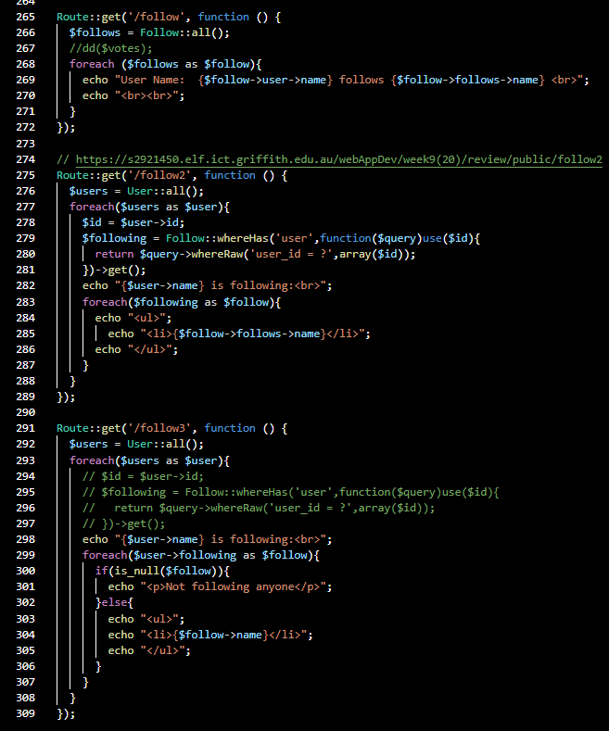

In order to effectively fulfil the criteria the design method chosen in this assignment was to create relational functions that use eloquent ORM capability rather than store related data in every table. The approach chosen in this assignment is illustrated by the code snippets below.

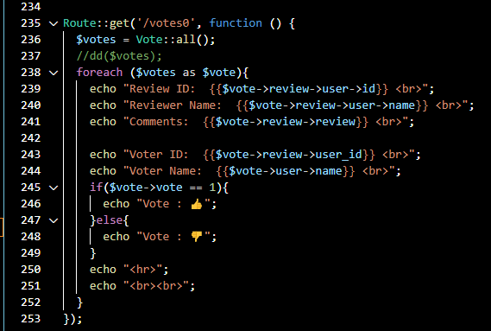

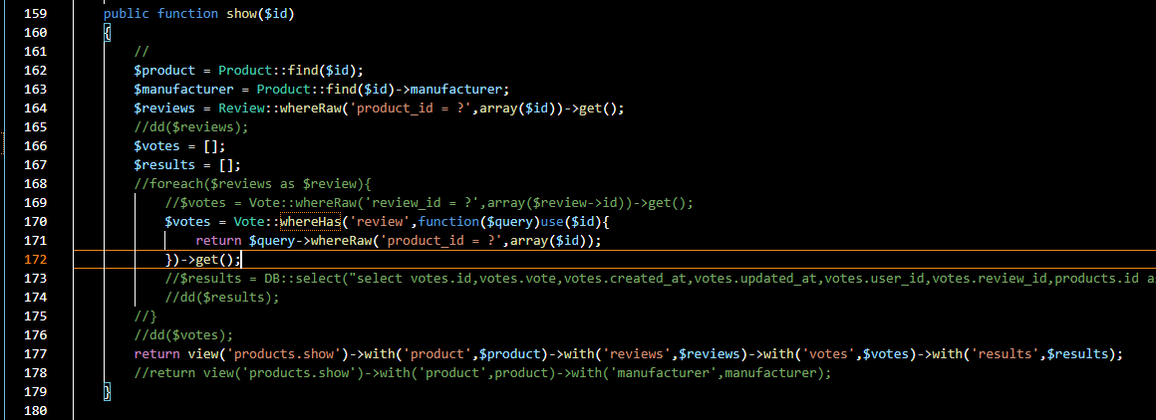

Test first development using models and routes was used to develop the controller functions initially. Views were added to obtain instant feedback rather than reloying on SQL commands on the terminal to test CRUD commands.

Before any code was written sequential pseudo-code design was made to avoid the program from crashing due the foreign key violation constraints. Algorithms were designed such that when deleting a product first the reviews and the votes (likes and dislikes) would be deleted first. Likewise, when deleting reviews the code ensured that the votes with the foreign keys referencing to the reviews are deleted first. This relationship is illustrated in the Entity relationship diagram below.

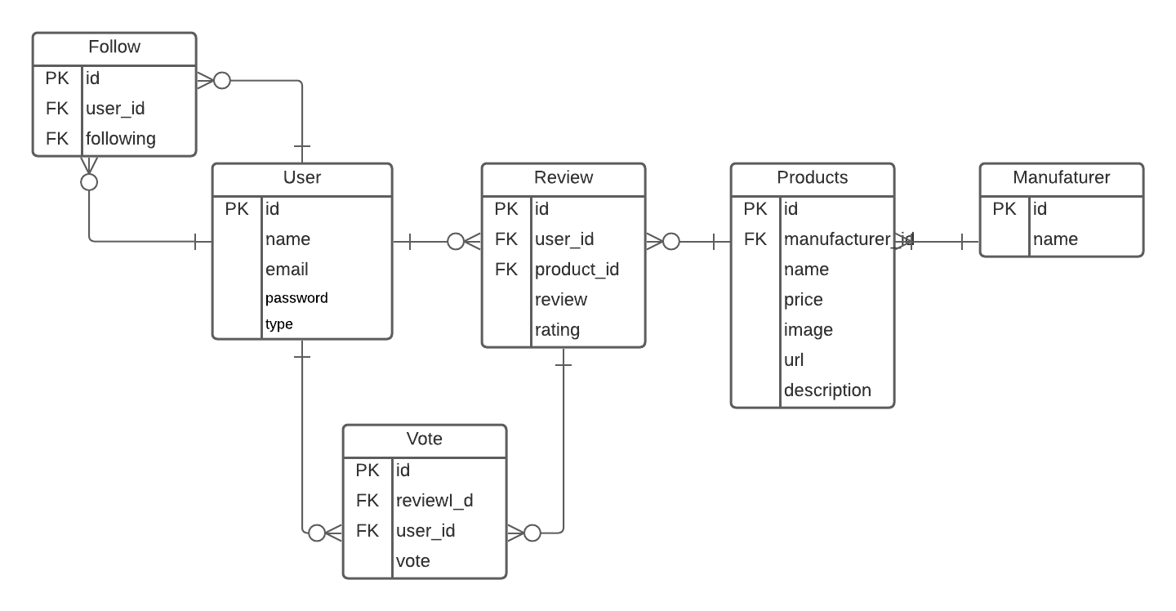

**Video Link**

<https://web.microsoftstream.com/video/2abc1cf2-3627-4b93-9ccc-f1e5fdf0224f>